Power BI Lab 3 Report
Dax Basics
Tamar Tutisani

Introduction
The objective of this lab is to explore and implement Data Analysis Expressions (DAX) basics within Power BI, building upon the foundational reports developed in prior sessions. This involves the creation of calculated columns, custom aggregations, time intelligence functions (YTD, PY comparisons), advanced analytical measures, and structured dashboard formatting.
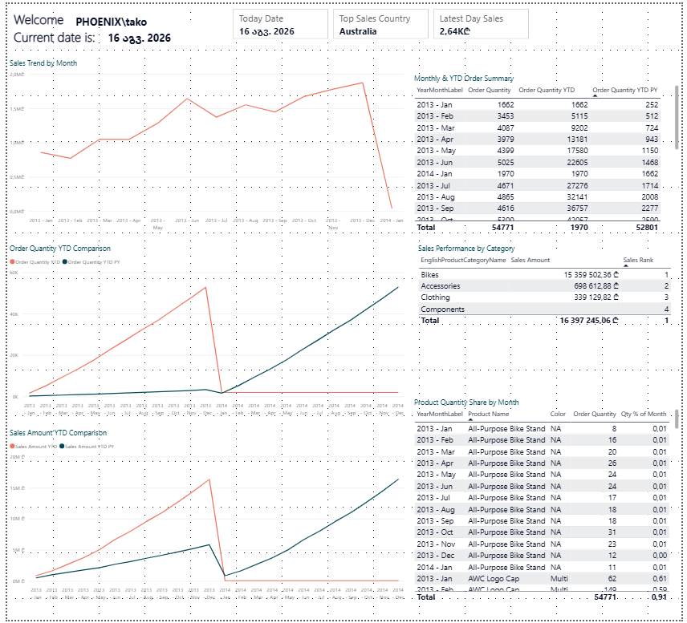

1.1 Creating a Calculated Column - "Year Month Label"
The first step involved creating a calculated column in the DimDate table to provide a user-friendly date representation. Using the FORMAT function, a column named "Year Month Label" was created with the formula:
Year Month Label = FORMAT('DimDate'[FullDateAlternateKey], "yyyy-mm")
This converts dates into readable month-year labels like "2010-Jul" for July 2010, making dates easier to interpret in visualizations.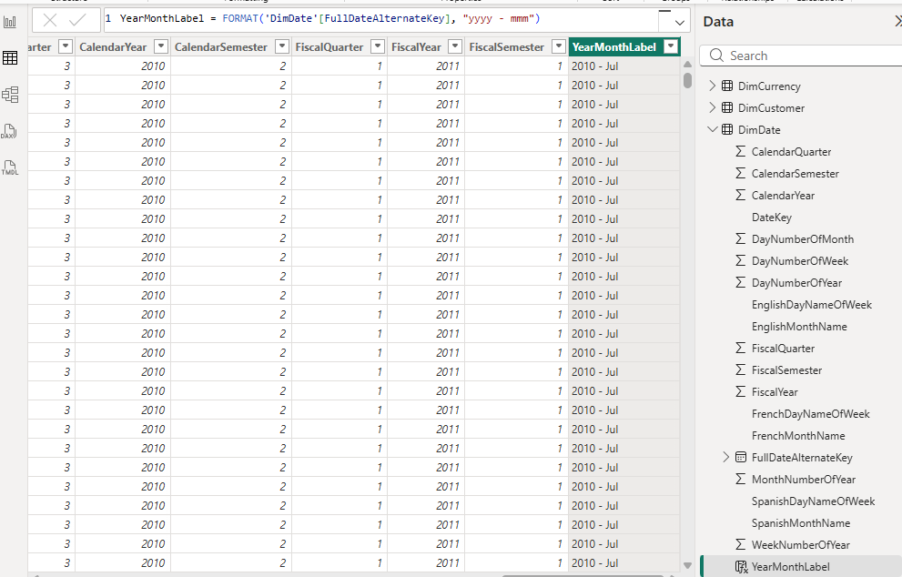
Screenshot 1. Calculated Column “Year Month Label”

1.2 Chronological Sorting via Custom Numeric Index
A line chart was created to visualize sales trends over time. Initially, OrderDate from FactInternetSales was placed on the X-axis with SalesAmount on the Y-axis. However, this created a date hierarchy (Year->Quarter->Month->Day) that cluttered the visualization.
To resolve this, a numerical sorting column was engineered to maintain proper chronological order.
The solution involved replacing OrderDate with the Year Month Label column and filtering to show only data from 2013 onward, resulting in a cleaner, month-by-month view of sales trends.
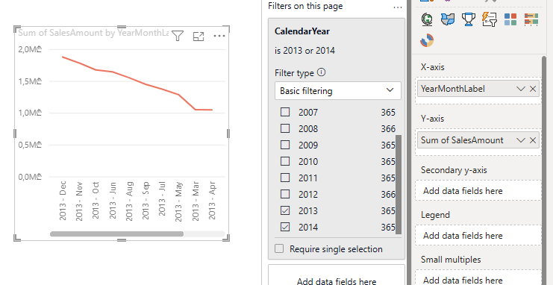
Screenshot 2. Products cost by YearMonthLabel

1.3 Solving the Alphabetical Sorting Problem
A critical issue emerged: the Year Month Label sorted alphabetically rather than chronologically (April, August, December, February, etc.). To fix this, a companion numeric column was created:
YearMonthNumber = ('DimDate'[CalendarYear] * 100) + 'DimDate'[MonthNumberOfYear]
This formula generates unique identifiers for each year-month (201301 for Jan 2013, 201302 for Feb 2013, etc.). By configuring Year Month Label to sort by YearMonthNumber, the chart displayed months in proper chronological order.
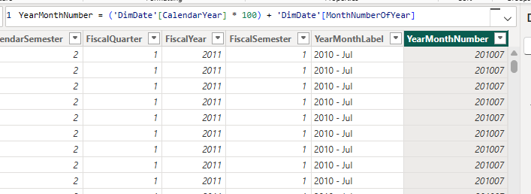
Screenshot 3. YearMonthNumber column formula
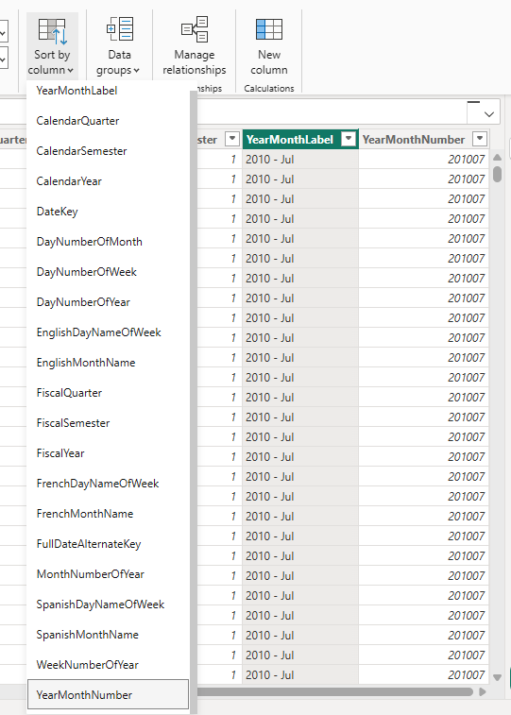
Screenshot 4. Sorting by new YearMonthNumber column
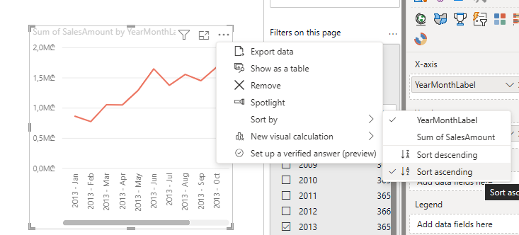
Screenshot 5. Historically sorted Line Chart

1.4 Creating Simple Measures
The Today Date measure was built using:
Today Date = TODAY()
This returns the current date and was added to a Card visualization with formatting applied to display dates as dd/mm/yyyy.
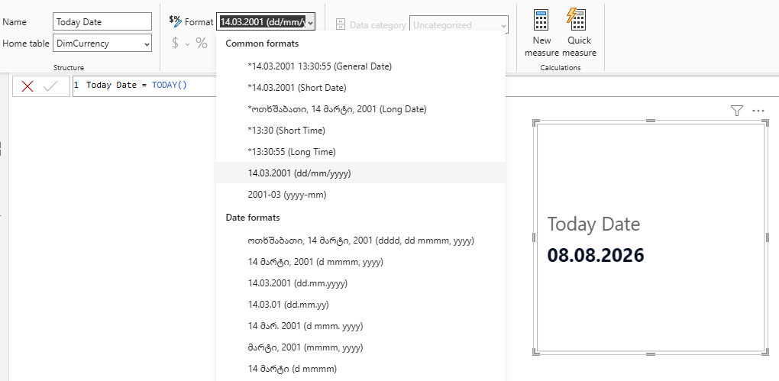
Screenshot 6. Formatted Today Date

The Order Quantity measure was created to sum all OrderQuantity values:
Order Quantity = SUM('FactInternetSales'[OrderQuantity])
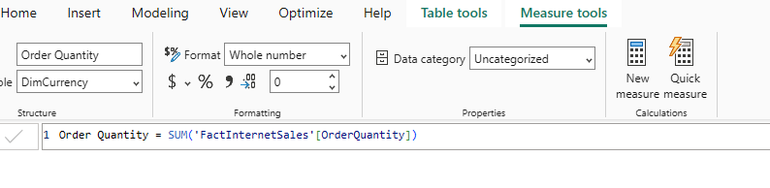
Screenshot 7. Added a new measure – Order Quantity

1.5 Year-to-Date Calculations
The Order Quantity YTD measure calculates cumulative order quantities from the start of each year:
Order Quantity YTD = TOTALYTD([Order Quantity], 'DimDate'[Date])
TOTALYTD automatically resets at year boundaries, allowing month-to-month cumulative tracking.
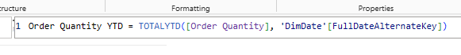
Screenshot 8. Added a new measure – Order Quantity YTD
To enable year-over-year comparison, the Order Quantity YTD PY measure was created:
Order Quantity YTD PY = CALCULATE([Order Quantity YTD], SAMEPERIODLASTYEAR('DimDate'[Date]))
This shifts the date context back one year, showing what YTD values were at the same point in the previous year.
Screenshot 9. Added a new measure – Order Quantity YTD PY

1.6 Verification Table
A table visualization was created containing Year Month Label, Order Quantity, Order Quantity YTD, and Order Quantity YTD PY. This table confirmed that each measure behaved correctly: Order Quantity shows monthly totals, Order Quantity YTD shows cumulative values resetting each January, and Order Quantity YTD PY displays prior-year comparison values.
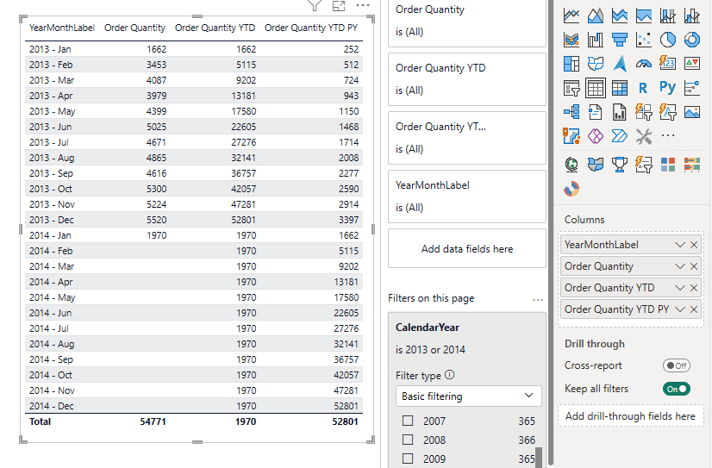
Screenshot 10. Table with all the measures

1.7 Sales Amount Measures
Following the same pattern, three corresponding measures were created for Sales Amount:
- Sales Amount = SUM('FactInternetSales'[SalesAmount])
- Sales Amount YTD = TOTALYTD([Sales Amount], 'DimDate'[Date])
- Sales Amount YTD PY = CALCULATE([Sales Amount YTD], PARALLELPERIOD('DimDate'[Date], -12, MONTH))
PARALLELPERIOD was used instead of DATEADD for the previous-year calculation, as it's specifically designed for period-to-period comparisons.
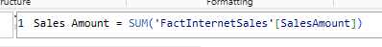
Screenshot 11. Created Sales Amount measure

Screenshot 12. Created Sales Amount YTD measure

Screenshot 13. Created Sales Amount YTD PY measure

Creating the Lab Report

2.1 Current User and Date Header
Two card visualizations were added to the top of the report. The Current User measure was built using:
Current User = USERNAME()
This returns the logged-in user's name. Combined with the Today Date measure, these cards displayed "Welcome PHOENIX\tako" and "Current date is: 08.08.2026" after removing borders for a clean appearance.
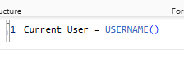
Screenshot 14. Added Current User measure

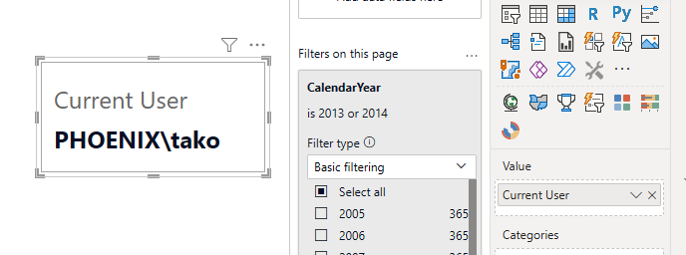
Screenshot 15. Current User Card

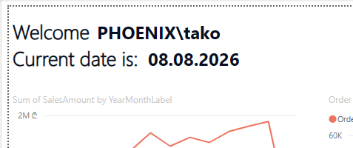
Screenshot 16. Username and Current date header

2.2 Year-to-Date Comparison Line Charts
Two line charts were created to visualize YTD trends:
- Chart 1 plots Order Quantity YTD and Order Quantity YTD PY against Year Month Label
- Chart 2 plots Sales Amount YTD and Sales Amount YTD PY against Year Month Label
Both charts enable side-by-side comparison of current-year and prior-year performance, clearly showing seasonal patterns and year-over-year growth or decline.
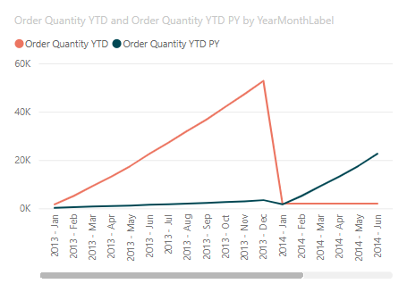
Screenshot 17. Line Chart for Order Quantity

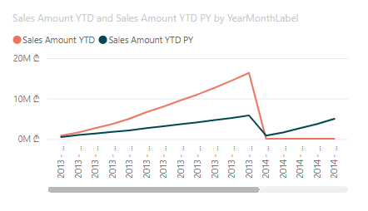
Screenshot 18. Line Chart for Sales

2.3 Product Details Table with Percentage of Total
A table was created showing Year Month Label, Product Name, Color, Order Quantity, and a percentage metric. The percentage was calculated using:

Qty % of Month =
DIVIDE(
[Order Quantity],
CALCULATE(
[Order Quantity],
ALLEXCEPT('DimProduct', 'DimProduct'[Color]),
ALLEXCEPT('DimDate', 'DimDate'[YearMonthLabel])
)
)
This divides each product's order quantity by the total quantity across all products, using ALL() to remove product-level filters. The result is formatted as a percentage, showing each product's contribution to monthly sales volume.
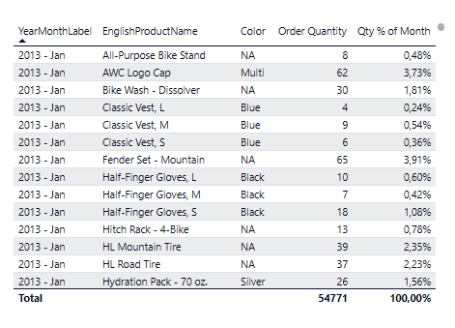
Screenshot 19. Table with Product Details

2.4 Advanced DAX Measures
Sales Amount for Latest Date:
Sales Amount Latest Date = CALCULATE([Sales Amount], 'FactInternetSales'[OrderDate] = MAX('FactInternetSales'[OrderDate]))
This measure filters data to show only the most recent date in the dataset. By using MAX() dynamically, the measure updates automatically if new data is added, eliminating the need for hardcoded dates.
Screenshot 20. Measure to show Sales Amount for Maximum OrderDate

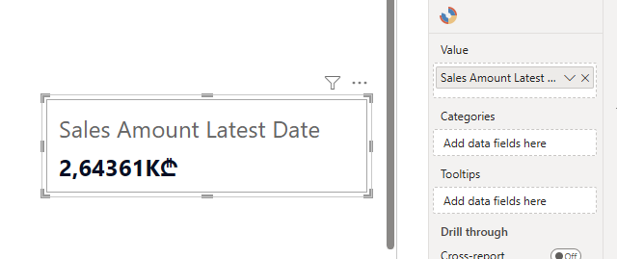
Screenshot 21. Card for the new measure

Country with Highest Sales:
Top Sales Country = MAXX(TOPN(1, ALL('DimSalesTerritory'), [Sales Amount]), 'DimSalesTerritory'[Country])
TOPN identifies the single country with the highest sales, and MINX extracts its name as text. This approach returns a readable country name suitable for Card display and updates dynamically if sales patterns shift.
Screenshot 22. Country with the Highest Sales

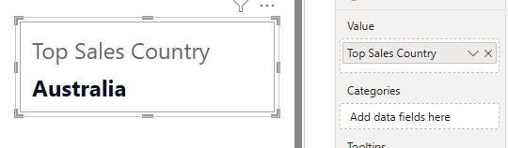
Screenshot 23. Card for the new measure

Product Category Ranking:
Sales Rank = RANKX(ALL('DimProductCategory'), [Sales Amount])
This calculated column (not a measure) ranks each product category against all others. Using ALL() ensures the ranking ignores external filters and remains consistent regardless of report slicing. The result shows Bikes (Rank 1), Accessories (Rank 2), Clothing (Rank 3), and Components (Rank 4) ordered by sales.
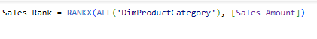
Screenshot 24. Measure to show Product Category Rank by Sales

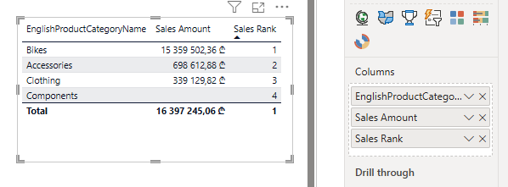
Screenshot 25. Using Rank measure to rank Product Categories

3. Conclusion
The lab demonstrated essential DAX techniques for business analytics. From simple FORMAT functions to complex time intelligence calculations like TOTALYTD and PARALLELPERIOD, the work showcased how DAX transforms raw data into actionable insights. The combination of calculated columns for sorting, YTD measures for trend analysis, and advanced functions for ranking creates dynamic, self-updating reports that respond to data changes automatically.

